**Synopsis**

**Face Recognition Attendance System**

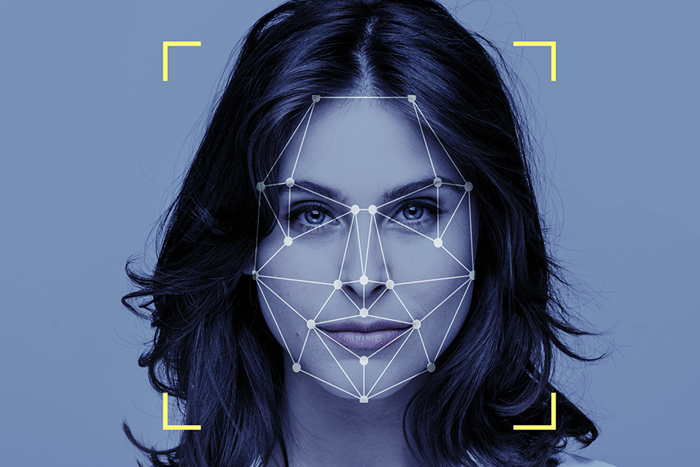

**Abstract**

The management of the attendance can be a great burden on the teachers if it is done by hand. To resolve this problem, a smart and auto attendance management system is being utilised. By utilising this framework, the problem of proxies and students being marked present even though they are not physically present can easily be solved. This system marks the attendance using a live video stream. The frames are extracted from video using OpenCV. The main implementation steps used in this type of system are face detection and recognizing the detected face, for which dlib is used. After these, the connection of recognized faces ought to be conceivable by comparing with the database containing student's faces. This model will be a successful technique to manage the attendance of students.

Live Webcam based Face Attendance System Project through python programming

**INTRODUCTION**

In today's world, the face recognition technique changes the biometrics field. In this technique, we use people’s faces for identification. As we know each person has unique facial traits so it’s very easy to differentiate or uniquely identify an individual. Face recognition, which has gallantly outperformed in a variety of disciplines, has the potential to be employed efficiently for security systems but has not been explored owing to obvious weaknesses. As we know, the traditional system which is pen-paper has its own pros and cons. The manual attendance marking method is susceptible and time demanding, resulting in a setback for the kids. . In order to address this issue, advances have resulted in the widespread usage of biometrics. As we know biometric technique for attendance comes at an uncomfortably high cost for users as well as very time-consuming on the user's part. So face recognition is a very valuable technology And develop strategies that incorporate it into our system.

passage of time, advances are also required to keep up with ever-increasing technology. Attendance Management with biometrics is being developed and adopted as multi- tech classrooms become more prevalent. As marking procedures advance, the notion under consideration is the urgent need to remove impediments, the complexity of devices, delays, and genuine attendance.

Unlike all traditional systems which are comparatively slow and susceptible, the InClass system employs face recognition to identify and note down the student attendance. In our system, there is no requirement for equipment further than a camera or laptop. The students' presence is validated via the use of their faces. This method is very effective for recording attendance and keeping the record with us or the person who is taking the attendance (Instructor, administration). . Algorithms are employed to match the student's faces with those in the database. In this system, we also use a mail function. We will help to store the attendance on the drive which is also helpful to reduce the usage of paper and whenever the record of attendance is required it can be fetched easily and any were.

**Face Detection**: Face detection is a technology that determines the location and sizes of human faces in an image. It detects faces and ignores anything else, such as building, chairs, and trees. It is a starting point for face recognition. Most of the face detection methods focus on detecting frontal faces. These methods are categorized into four types: Knowledgebase, Feature invariant, Template matching and Appearance-Based. Each method involves color segmentations, pattern matching, statistical analysis and complex transform. Face detection is an important part of face recognition as to implement the automatic face recognition

**Face Recognition**: Face Recognition is automatic identification or verification of a person from an image/video. It is one of the most active and widely used techniques because of its reliability, accuracy in the process of recognizing and verifying the person’s identity. Problem that may occur with face recognition are different people may look similar; characteristic of the face may change with time. Face can be recognized by two approaches that are based on geometry of face and based on appearance of face. The recognition process is done by comparing the extracted features from the image with the one previously stored in the database.

**PROBLEM DEFINITION**

Every time a lecture, section or laboratory starts the lecturer or teaching Assistant delays the lecture to record students’ attendance. This is a lengthy process and takes lot of time and effort, especially if it is a lecture with huge number of students. It also causes a lot of disturbance and interruption when an exam is held. Moreover the attendance sheet is subjected to damage and loss while being passed on between different students of teaching staff.

And when the number of students enrolled in a certain course is huge, the lecturers tend to call a couple of students name at random which is not fair student evaluation process either. Finally, these attendance records are used by the staff to monitor the student’s attendance rates. This process could be easy and effective with a small number of students but on the other hand dealing with the records of a large number of students often leads to human error.

##### **Advantages**

* The software can be used for security purposes in organisations and in secured zones.
* The software stores the faces that are detected and automatically marks attendance.
* The system is convenient and secure for the users.
* It saves their time and efforts.

##### **Disadvantages**

* The system don’t recognize properly in poor light so may give false results.
* It can only detect face from a limited distance.

**Project Requirements :**

**Software Requirements**

IDE : Visual Studio Code

Program : Python

OS : WIN, MacOX, Ubuntu

**Hardware Requirements**

RAM : Min 4 GB

ROM : Min 256 GB

System : Intel or Mac

Camera : Webcam or any inbuilt camera